



**Fundraising Pack**

**This is your opportunity to *Get Involved!* and make a difference to a successful local charity…**

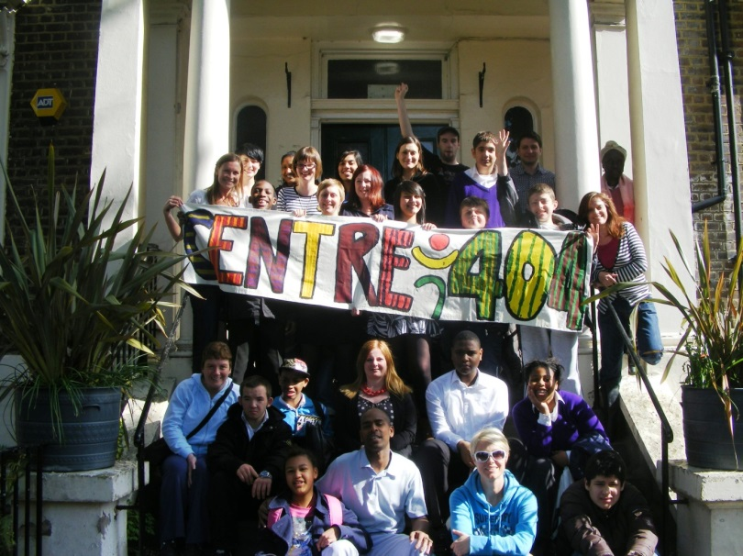

**CONTENTS**

1. **About Centre 404**
2. **Ways to *Get Involved!***

* **Personal Challenges**
* **Volunteering**
* **Fundraising**

1. **Personal Challenges & Sponsored Events**

* **5 steps to completing your personal challenge**
* **Choosing a Personal Challenge**
* **Setting up a fundraising donation page**
* **Where does your money go?**
* **Fundraising tips**
* **How we will support you along the way**

1. **Other fundraising ideas**
2. **Success Stories**

**1. ABOUT CENTRE 404**

Centre 404 was founded in 1951 by parents of children with a learning disability.

Based in Islington we support children and adults with a learning disability and their family carers to access support and activities that improve their quality of life.

Over the years we have built vital services and developed a high reputation for providing quality services in supported housing and independent living projects, social and educational clubs and activities, support for family carers and by providing opportunities for volunteers.

Last year we supported over 1,300 individuals and families to have more independence and choice in their daily lives by:

* Supporting adults to live independently in their own home or shared accommodation and to get out and about in their local area
* Running fun and stimulating after-school, evening & weekend clubs and activities and organising holiday play schemes
* Providing information, advice, advocacy and case work to carers and hosting social events for families.

**2. WAYS TO GET INVOLVED!**

By getting involved as a volunteer or by fundraising for us you will be making a real difference to improving the life experiences of the people that we support.

We receive grants from Local Authorities and Trusts to deliver our core services but we also rely on the kind and generous contributions of our volunteers and fundraisers to add value to the work that we do.

You can make a real difference to our community in a range of ways…

* **Personal Challenges**

Personal Challenges are a great way to help us fundraise. They can be anything from taking part in a walk-a-thon or fun-run to serious sporting events like marathons, triathalons and endurance events. If you or your friends are thinking of completing a personal challenge why not do it for charity! See section 3 for more information.

* **Volunteering**

We have many interesting and rewarding opportunities for people to support our work from helping out at clubs and activities and supporting people on outings to helping out in our garden and in the office or by being a trustee or committee member. More information on all our volunteer opportunities can be found on our website at <http://www.centre404.org.uk/volunteer> or you can call the office on 020 7607 8762 to find out more.

* **Fundraising**

If you want to set up your own fundraising or community event for Centre 404 go to section 4 for some ideas and tips.

**3. PERSONAL CHALLENGES & SPONSORED EVENTS**

* **5 steps to completing your personal challenge**

1. Choose a Personal Challenge – there are so many sponsored events out there to choose from fun-runs, walks, cycle events and marathons, see our list below for some ideas.
2. Get in touch with us at [general@centre404.org.uk](mailto:general@centre404.org.uk) or phone us on 020 7607 8762 and tell us what you want to do, we can then help you register for the event and support you along the way
3. Set up a personal online fundraising page this will help you promote your event to all your contacts easily and it allows people to make donations and pledges online. You may have an online giving account already set up or you can use our Just Giving account (see for more details below)
4. Start Fundraising – This is the fun part and on those early mornings when you are getting up to train it can really help to keep you motivated to see your fundraising total grow and to know that you are making a difference to people’s lives. As well as an online fundraising page you can set up things like Quiz Nights or cake sales for your friends or local community. See section 4 for more fundraising ideas and tips.
5. Complete your personal Challenge – The BIG DAY, after all the training and hard work you will finally get to achieve your goal. Sponsored and sporting events are a great day out so why not invite your friends and family along to see you cross the finish line! Where possible Centre 404 staff and supporters will come along to cheer you on as well.

We are always so grateful to people who are willing to give up their precious spare time to take part in sponsored personal challenges and we will do everything that we can to support you along the way.

* **Choosing a Personal Challenge**

Here are just some of the events that you could sign up to. If you have a specific event in mid it might be worth checking their website first to check if there are any restrictions in relation to what charity you want to raise money for.



* **Setting up a fundraising donation page**

It couldn’t be easier to set up your own personalised online fundraising page.

Go to <https://www.justgiving.com/centre-404> and click on ‘Fundraise for us’ (top right hand side of screen). You will be taken through the process step by step and have the option of adding your own personal messages and images.

We can also provide paper sponsorship forms if you want to use these instead.

Once the page is set up you will have your own unique url which you can email to all of your contacts and friends. They can then make a donation or pledge to sponsor you for the event. Sponsors will also have the opportunity to increase their donation with Gift Aid which means we can claim back some tax on their gift.

We do not usually stipulate a minimum fundraising target but we recommend that you set yourself a goal as this helps you and your friends and family focus on what you want to achieve.

For some events that require us to pay a registration fee we may stipulate a minimum fundraising target to ensure that we can cover any associated costs. It helps us if you can pay any registration fees to join the event yourself.

* **Where does the money go?**

All fundraising costs are kept to a minimum. Donations received through sponsored activities are used to subsidise and improve our clubs and activities or to improve our facilities and equipment (for example to purchase play or sensory equipment).

If you want to know what your fundraising will be used for we can discuss this with you when you register, you can then decide if you want to fundraise for a particular service or piece of equipment for example.

See section 4 for more examples of how your fundraising and donations might be used.

* **Fundraising tips**

Set an achievable target

Ensure that the event you are entering or setting up is achievable. Ask around for ideas and support from others then set a goal and communicate it so that you stick to it.

Start early and get planning

Make a training plan and stick to it or if you are setting up your own event write out key tasks and deadlines to ensure you keep on track.

Make sure you have the right equipment

It’s obvious, but you can’t run without the right running shoes, you can’t cycle without a bike, you can’t sky dive without a parachute, and you can’t set up a cake sale without plenty of cakes!!

Train hard or carry out a small practice run

Organising a cake sale, so why not test your cakes out on your family first? Running a marathon, make sure you carry out plenty of training so you do not cause any injuries to yourself along the way.

Create a sponsorship page

This is the easiest way to make sure you reach all your contacts, friends and family to promote you event and watch your fundraising total grow.

Spread the word, drum up support, increase your support base

Why not create your own posters or hand out Centre 404 leaflets at school, clubs, and church or at your workplace.

Create a team and make new friends

Why not partner up with other people at school or at work? You could enter a team event or setup a sponsored event of your own. Check out our A-Z of sponsored events for ideas attached.

Ask everybody for sponsorship

Do you have a corporate sponsorship programme? Some employers will match the money you raise, so why not ask and find out!

* **How we will support you along the way**

**Before the event**

Once you have signed up or told us about your fundraising idea we will send you a fundraising pack and let you know who at Centre 404 will be supporting you with your fundraising.

We will take your contact details and stay in touch with you in a way that suits you, we can stay in touch by email or phone to help you with your fundraising and to keep you informed off any relevant information about the event i.e. meeting points, start times, how to order a Centre 404 t-shirt and so on.

We will promote your event on our social media and newsletters.

We will help you set up an online fundraising page and offer advice or materials where we can to assist you with your community fundraising.

**During the build up to the event**

We will be in touch with your regularly with any updates from the event organisers.

We will organise and provide a Centre 404 running T-Shirt.

We will let our staff and supporters now about your event and try where practical to organise for someone for Centre 404 to be there for you on the day to support and cheer you along.

**After the event**

We will feature your achievements in our newsletter and social media. We will ask you in advance for a photo (optional) and a few words to describe your experience and for feedback about the event and the support that you received from us.

You will get copy of the newsletter and we will ask you how you would like to stay in touch with Centre 404 in the future.

**4. OTHER FUNDRAISING IDEAS**

**Organising your own fundraising event is a great way to get to know your local community while raising money for a create cause. See our alphabet of ideas attached. Here are just a few great ideas:**

* **Raffle/tombola**
* **Ball, dinner or dance**
* **School fete or cake sale**
* **Quiz Night**
* **Spell-a-thon**
* **Talent show**
* **Sponsored silence**

**Contact us if you are want to set up your own fundraising event on 0202 7607 8762 /** [general@centre404.org.uk](mailto:general@centre404.org.uk)

* **Examples of how your fundraising can help**

**£10** could fund transport and membership for 4 people with learning disabilities to attend the Friday Night Social. This weekly disco for over 16’s might be the only opportunity some people get to see their friends and socialise

**£50** could fund a professional to deliver an animation workshop to a group of 12 children with learning disabilities in our after school clubs

**£100** could cover expenses for after school group activities like swimming and a meal for 12 young adults with a learning disability for 2 months

**£200** could go towards the costs of new equipment like musical instruments and games consoles for our children’s groups, sensory equipment for people with high and complex needs, or computer equipment for volunteers to use

**£1000** could cover the costs of staffing and running our weekly Men’s Group that provides an opportunity for vulnerable adults to develop friendships and meet up to do things like go bowling, go to the cinema, meet up for pizza or go to the pub and watch the football.

**5. SUCCESS STORIES**

Over the years, we have had some exceptional people completing their personal challenges and raising much needed funds for Centre 404. Here are just a few of our success stories.



Santa Run December 2013 – Victoria Park London.

**Michael Walmsley and Ryan Pickard** were corporate volunteers with Centre 404 and helped us to develop this sponsorship pack and materials. They joined some of our staff and service users on the Santa Run 2013 and raised almost £2000 that was used towards the installation of our sensory room.

**Joseph Greene** has been a service user at Centre 404 for many years. He attends our men’s group and Friday Night Disco. He is also a volunteer and member of staff. He has run the BUPA 10k twice for Centre 404. In 2011, he raised £400 and in 2013 he raised £948.

**Derek Weist** is Centre 404’s Treasurer and a member of our board. Taking up running at the age of 50, in 2013 he ran the Reading Half marathon for Centre 404 raising £1,087 for our Centre 404 garden and garden project for people with learning disabilities.

**Lucy Zecchin** works at the local Puregym and got in touch with Centre 404 in 2013 as she decided to do the London to Brighton bike ride raising £560 for new sports equipment for Centre 404’s clubs.

**Lisa Pook**, a veteran marathon runner, first started volunteering for Centre 404’s garden project in 2012. She decided to raise money for Centre 404 while doing the Edinburgh Marathon in 2013 and as a result of running in all weather including hail, snow and sleet; she raised £582 for Centre 404.

**Matthew Bull**, an Islington local – born and bred, ran the London Marathon in 2012 for Centre 404. He also was creative with his fundraising and put on his own alternative walk in Islington and Sunday roast. As a result of all his efforts he raised £1,400.

**Kalpesh Patel’s** younger brother Bhavin attends our Happy Tuesdays Group and he decided to run the 2012 London Marathon and raised £1,848 for Centre 404.



**We hope this has inspired you to set your own personal challenge or organise a fundraising event. Please contact us if you want to *Get Involved!***