Centre 404 Quality and Driving Up Quality Sign Up Page

At Centre 404 we are committed to the quality of the support we provide. We aim to be ambitious and innovative in our commitment to prioritise the needs and wishes of people with learning disabilities and their families. We have signed up to the Driving Up Quality Code which aims to drive up quality in services for people with learning disabilities and we are pledging to provide high quality, values-led services.
To find out more about the code and the key standards click here.
Over the next 12 months we will be completing our self-assessment and will be gathering feedback from service users, family members, staff members, trustees and the professionals we work with. The feedback will help us to assess how well the support services we provide are meeting the 5 key standards.
We will reflect on areas where we can develop and also celebrate and build on the achievements we have made. Our feedback will be put into a report containing information on how we are meeting the key 5 standards and how we aim to develop the quality of our support services.
- We have completed our Annual Survey, to see our report and action plan download these here.
- We have signed up to the Social Care Commitment. Please find out more details on their website here.

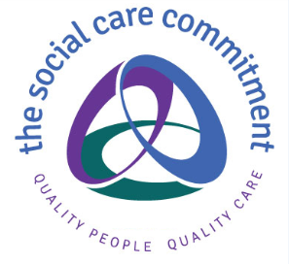

- We are rated as Good with CQC. Download our CQC report here.

